NEIGHBOURS PUSHING TORRELODONES FROM A TYPICAL SUBURBAN SPRAWL TOWN TO A LIVELY SMALL CITY IN THE METROPOLITAN AREA OF MADRID

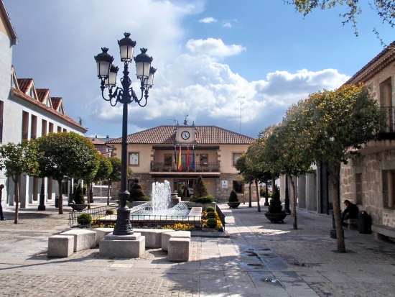
Torrelodones (link in Spanish) is a wealthy medium-sized town in the metropolitan area of Madrid, located in the vicinity of a natural area of great environmental and landscape value. With close to 23.000 inhabitants, the city has rapidly grown in population over the last fifteen years. It has doubled its number of inhabitants in a context characterised by the lack of an urban planning strategy, a huge housing boom across the country and a revealed politicians’ preference for large-scale equipments. Particularly in Torrelodones, urban growth has been based on single family houses, located far from the two urban centres in which the city is divided. More than 75% of the houses are single family units. It is therefore an area with all the characteristic features of the suburban sprawl: high motorisation rates, car-dominated mobility patterns and a urban space that deters socialization and play.
«Torrelodones. Plaza de la Constitución» by Paconi – Own work. Available under the licence CC BY-SA 3.0 via Wikimedia Commons - https://commons.wikimedia.org/wiki/File:Torrelodones._Plaza_de_la_Constituci%C3%B3n.jpg#/media/File:Torrelodones._Plaza_de_la_Constituci%C3%B3n.jpg
POLITICAL CHANGES
In 2011, a neighbourhood party emerged and surprisingly got the town government, changing its priorities and focusing on the creation of attractive public spaces, reducing car mobility and promoting walking and cycling, while preserving the heritage and environmental richness of the municipality.
As a starting point, in 2012 the city issued a Sustainable Urban Mobility Plan (link in Spanish), developed with an intense public participation process, which set as a medium-term target the change towards a less motorized mobility model.
Following this Plan, within which a pedestrian and cycling network were defined, as well as a traffic calming strategy, in 2012 and 2013 an ambitious program of interventions was put in place, focusing on the surrounding and interconnection of key locations such as schools, sport centres, cultural buildings, etc. The municipality was assisted by our National Focal Point gea21 in the coordination and design of the action plan.
Given the tight budget available, together with the threat of political and public opposition against the significant change of priorities, the efficiency of the measures was maximised either through a thorough selection of critical locations or the design of ‘low-cost’ interventions. In all cases the active participation of the population was sought, also during the design phase (for example, through a participatory artistic intervention for the improvement of a school environment).
THE RESULTS
Both technical and public assessment of the actions undertaken were very positive, which lead to a renewed and increased support towards the neighbour party ruling the city in the 2014 municipal elections. This has resulted in a second program of interventions for the period 2014-2016, currently under development.
Find below a few examples of the measures implemented in Torrelodones:

PEDESTRIANISATION OF SCHOOL AREA
Before
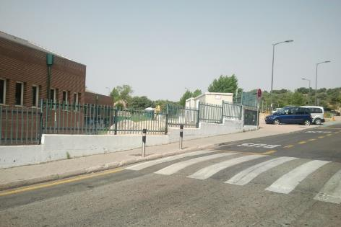
After
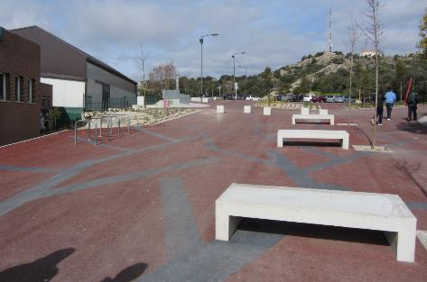

IMPROVEMENT OF LENGUAGE SCHOOL AREA
Before
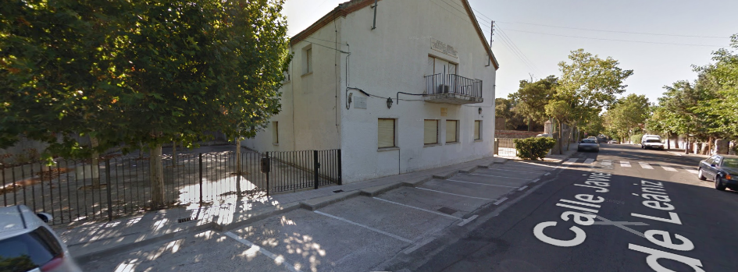
After
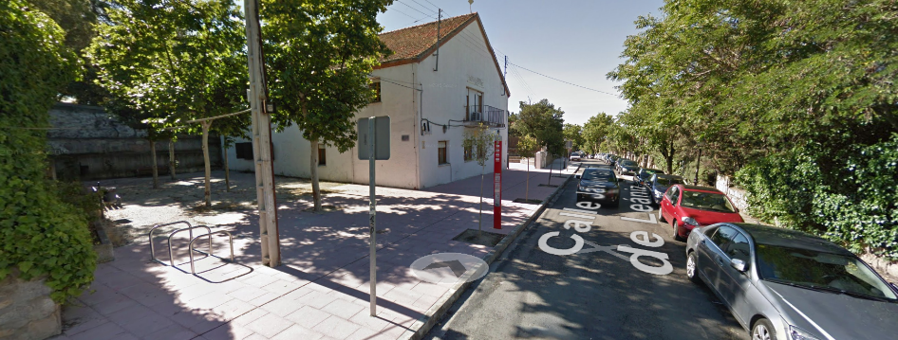

PEDESTRIAN IMPROVEMENT AND SAFER CROSSING
Before
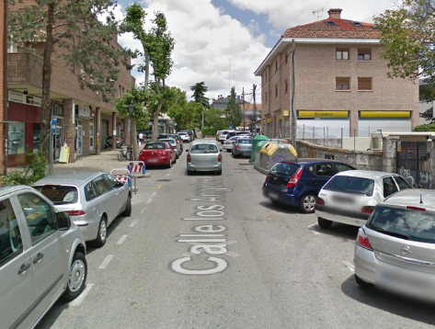
After
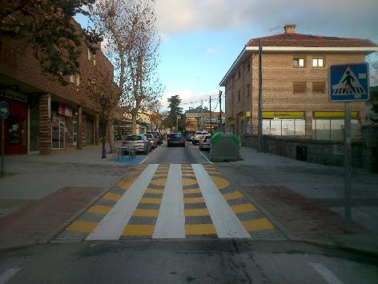

PEDESTRIAN IMPROVEMENT AND TRAFFIC CALMING
Before
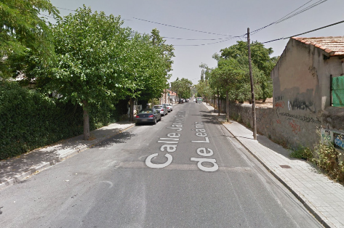
After
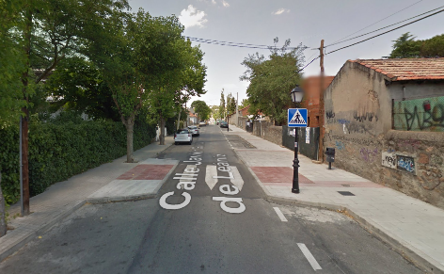

SAFETY IMPROVEMENT AT JUNCTION
Before
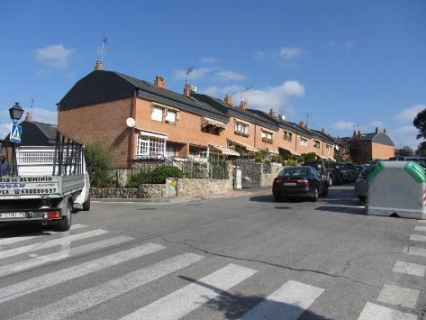
After
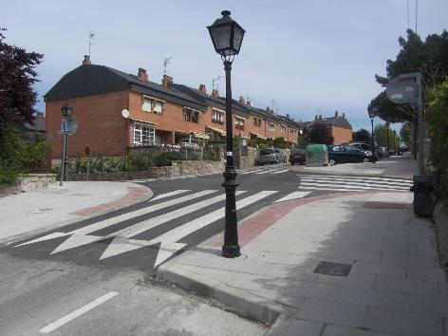

CYCLING IMPROVEMENT
Before
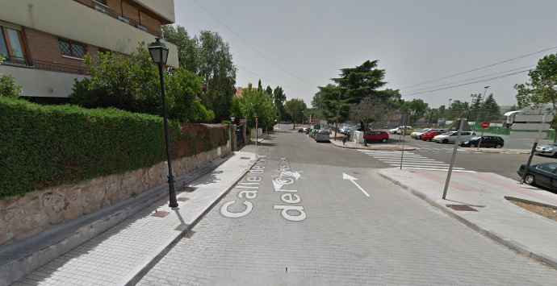
After
